Early Number Systems

Ancient Egypt
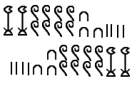
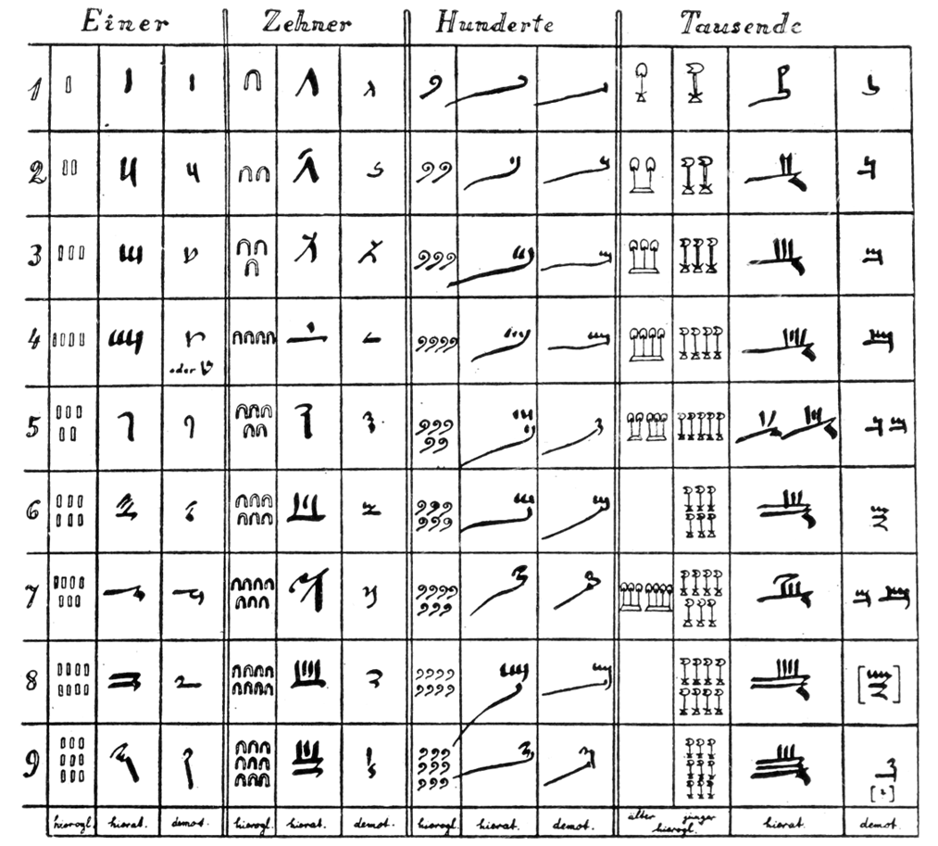
The Egyptian numeral system is recorded on artifacts and papyrus, the oldest of which is estimated to be from around 3000 B.C. There were three different systems for numbers, the hieroglyphic, hieratic and demotic numerals. The hieroglyphs were used when numbers were being carved, appearing frequently on artifacts and tomb walls. Later, the hieratic and demotic forms developed, and were primarily seen on ink and papyrus. The hieroglyphic numerals were repeated to indicate the magnitude of each power of 10. The hieratic form on the other hand had distinct symbols for each power.
Figure 1: Egyptian Numerals
The Arabic number system that we use has positional relevance when it comes to the ordering of numbers. Switching digits around would change the magnitude of the number that they represent. The position of the hieroglyphic numerals on the other hand was irrelevant to the magnitude of the number that it was trying to represent. They were often found with decreasing orders written in both directions, and top down vertically.
Many of the systems that the Egyptian numerals used were lost to time and replaced with more effective number systems by the early first millennium. The mathematics they were doing with their number system, however, would be very familiar to the modern student. The Rhind papyrus was an ancient text discovered in the 1800’s that dates to 1550 B.C. It included mathematics from arithmetic and fractions to geometry and word problems.
Figure 2: Egyptian Directionality

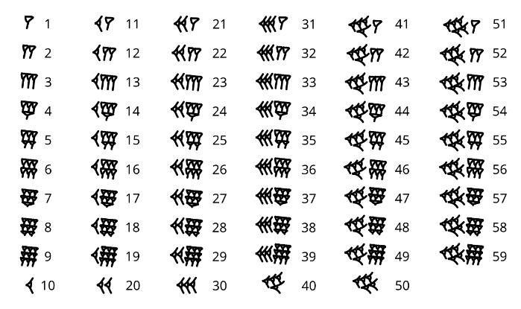
Babylonian Numerals
Figure 3: Babylonian Numerals

The Babylonian numeral system originated around the year 1800 B.C. in what is modern day Iraq. It was written in Babylonian cuneiform, which was written by making indentations in clay with a rectangular stylus. On the right, one through nine would have been vertical lines made with the edge of the stylus, while multiples of 10 would have been made with it’s corner. The system is particularly important as it’s believed to be the first positional number system. To represent numbers larger than 59, a second group of markings would be started to the left of the base group to represent the number of 60’s, so on and so forth. This made the babylonian numerals a sexigesimal system.
$$\left(12\left(60\right)+15\right)$$
$$+ \left(13\left(60\right)+24\right)$$
$$=\left(25\left(60\right)+39\right)$$
Figure 4: Babylonian Higher Orders
The positional ordering of the numerals greatly simplified arithmatic for the ancient babylonians. Firstly, the positional ordering system allowed for much simpler addition and multiplication, being performed by one order of 60 at a time. Secondly, the numbers could easily represent values less than one. In the same way that we a decimal place along our base 10 digits to represent values less than one, the base value of the baylonian numeral system could be treated as less than one, and the arithmetic’s difficulty would be unchanged.
The base 60 fractional system that was employed by the Mesopotamians with their numeral system lives on today in our degrees. 360 degrees from the 6 whole arcs of a circle, 60 arc minutes and 60 arc seconds were used by the Mesopotamians and has likely stuck around because of the base’s easy fractional divisibility.

Greek Ionic Numerals
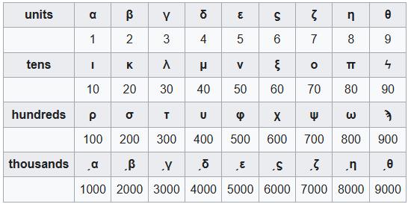
The Greek Ionic numerals were popularized around 400 B.C. The Attic Numerals, which resemble Roman Numerals, were phased out likely due to the advantages of the ionic numerals. The numerals were base 10 and they were the first alphabetic numerals to see widespread use, which had many advantages over previous number systems. Ionic numbers, when compared to their predecessors, were much more succinct. In more symbolic numeral systems like the Babylonians’, the number of marks required to represent large numbers could easily get out of hand. An Ionic system remedied this issue by assigning a letter to each unit, and multiple of 10, 100, 1000 to remove the need for repeated symbols. This combined with their positional ordering made the arithmetic of large numbers significantly easier.
$$\overline{,βωλδ}=2834$$
$$\overset{α}{M}∙\overline{α}=10,001$$

Figure 5: Ionic Numerals
Figure 6: Ionic example
The relation of letters to numbers also gave rise to a practice called isopsephy. It was a process by which words are represented as their alphabetic numbers either as is or as summations of their parts. This practice was used to connect sentences or ideas that shared the same sum of their parts. The most famous of which being the mark of the beast in the New Testament of the Bible, whose letters correspond to the number 666. It was indicated this way in the original Greek manuscripts with the overbar that you would expect from a numerical value.
Figure 7: isopsephy of the Mark
$$\overline{χξς}=666$$
While Ionic Numerals didn’t directly influence the Arabic Numerals that we use today, it similarly realized the effectiveness of defining each decimal place for large numbers.

Roman Numerals
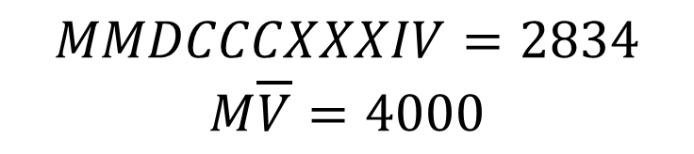
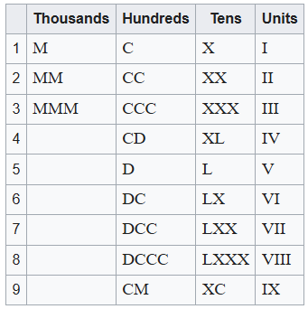
The exact period in which the roman numerals that are popular today originated from is a heavily debated topic by historians, as they appeared to draw influences from the Etruscan numerals and evolve into the number system that is most referred to today. The roman numerals are base 5 and 10 called bi-quinary, employing repeated decimals in addition to a distinct 5th digit to represent numbers. Numbers are summed from left to right when subsequent numbers are less than or equal to their predecessor and are subtracted from the total when they increase. In addition, numbers greater than 3000 are noted as the units with an overbar, indicating a 1000 times multiplication.
Figure 8: Roman Numerals
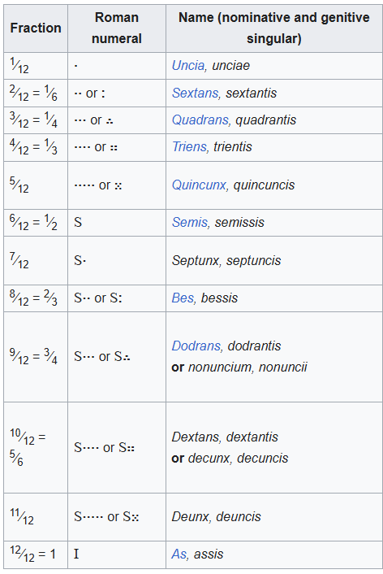
Romans used a separate numerical system when representing fractions. It was a duodecimal system, as it allowed fractions like 1/3, 1/4 and 1/6 to be represented much easier than the biquinary system. It counted up in 1/12 notated as dots and had a separate symbol S for 6 units.
Figure 9: Roman Example

Hindu/Arabic Numerals
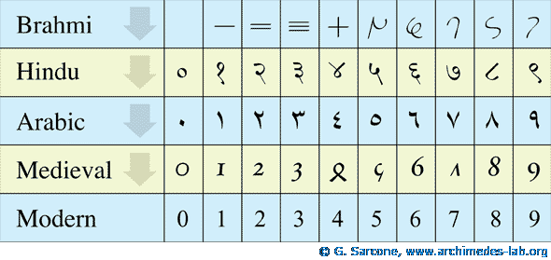
The Hindu/Arabic numerals numeral system was first

(Merzbach & Boyer, 2011, p. 9) Figure 1, Kurt Sethe
(Merzbach & Boyer, 2011, p. 25)
(Merzbach & Boyer, 2011, p. 53)

